Wholesale Accounts

I offer wholesale pricing to retailers with verified brick and mortar location in a relatable business, certificate of good standing from Secretary of State website, and letter showing EIN number issued from IRS.gov.
Please contact me directly via the site email for details and to set up your account.
Ladytruesoapco@gmail.com or call 719-922-1246.
To set up your account directly from the LadytrueSoapco.com website:
- Email the required documents to Ladytruesoapco@gmail.com Once accepted, the next step follows. I typically respond in up to 48 hours.
- Set up your account using your business email address and contact information and advise me of your email address so I may add it to my contacts list for wholesale pricing.
- Setting up your contact information triggers wholesale pricing in your order.
- Shipping is added at time of purchase. I look for the best shipping rates.
Thank you for your business.
Together we can grow!
Maureen Trujillo
Lady True Soap and Body Care
A division of Spirit Medicine Soap Co.

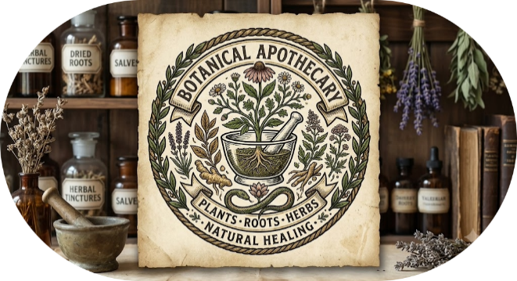

Lady True Soap and Body Care Co.
Est 1996 – A family tradition passed on through many generations~
Lady True Soap and Body Care Co. of Spirit Medicine Soap Co.
~Est 1996 – A family tradition passed on through many generations~
www.ladytruesoapco.com
Thank you for your interest in my naturally sourced products.
I produce soaps that are made with high quality food grade oils, herbs, roots, essential oils. Some are made with scented oils that are extensively tested for safety in soap making.
My product line consists of soaps, healing balm, and salves.
I have a very distinctive way of wrapping the soaps and all come in a beautiful colored organza bag that can be repurposed as a soap bag for exfoliating and skin polishing.
Sometimes the soaps will be wrapped in paper in its organza bag. This is because these soaps might have been recently made and they benefit from exposure to more air. The longer a soap dries, the harder it gets and more long lasting.
Products:
2020 Healing Balm – made with ten of the world’s most powerful essential oils blended into a multivitamin salve base.
O - Osha Anise soap. This is also known as the Biscochito Soap, fondly called this by my friends in the San Luis Valley of Colorado. 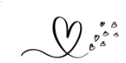
L – Lavender Soap. Made with fresh lavender and scented with essential oil of lavender, Spearmint and Tea Tree Oil.
OAT – Oatbars. Made with nourishing oils, skin loving essential oils, and ground oats.
SC – Tibetan Black Salt and Charcoal – scented with ground eucalyptus and essential oil of eucalyptus.
TR – Trementina (Pine Tar) made with pine tar in a soap base of high quality fats (manteca) and oils.
R – Rose – Made with high quality rose scented oil in a soap base of nourishing oils.
P – Plumeria. Scented with Hawaiian Plumeria in a soap base of nourishing oils.
GK – Gold Key - Inspired scent by Armani Code. Woody, spicy, warm, based with floral and citrus undertones.
SB - St Bridgid - a vetiver inspired scent that is a complex of earthy, smoky, and woody scent, with grassy and fresh, green undertones.
Recommended Pricing: Soaps - $8.00 or bundle 6 for $40 (bundle term for retail purchase only), Healing Balm - $15.00. Indica or Trementina Salves: $30.00.
Business purchases for resale/bulk order terms and pricing (keystone model used for 50 or more units, requires verified brick and mortar location in a relatable business, certificate of good standing from Secretary of State website, and letter showing EIN number issued from IRS.gov or Form I-9.

